Student Name: __________________
Class and Section __________________
Total Points (10 pts) __________________
Due: Feb 23, 2011 before the class

Project: JSF (Simple Calculator)

CSCI 5520 Rapid Java Application Development
Armstrong Atlantic State University

Problem Description:

Write a calculator to perform addition, subtraction, multiplication, and division, as shown in the following figure.

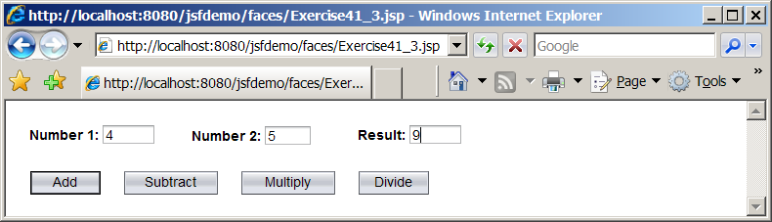

Name you servlet Exercise33_03.

Copy and paste Exercise33_01.xhtml + Exercise33_01.java here and also to LiveLab:

Show a screen shot of your sample run

Self-Evaluation:
- Is your UI created correctly?
- Is the Add button implemented correctly?
- Is the Subtract button implemented correctly?
- Is the Multiply button implemented correctly?
- Is the Divide button implemented correctly?

What to submit?

- Copy of this document.
- Save/Compile Exercise33_03.xhtml + Exercise33_01.java on LiveLab. You may get compile errors, ignore them. Continue to submit it. I will enter a score later.

